
PABSON Kathmandu
MID TERMINAL EXAMINATION-2082

Subject: Science & Technology Full Marks: 75
Class: 10 Time: 3 hrs.
Candidates are required to answer the questions in their own way words as far as practicable. Figures in the margin indicate the full marks.

Attempt all questions.

Group-A

Multiple Choice Questions:
1. Choose the correct alternative for the questions given. 10×1Ö 10
a) A group of students wants to find out whether the type of soil affects the growth of tomato plants. They planted tomato seeds in three different types of soil: sandy, clay, and loamy. Each pot received the same amount of water, sunlight, and fertilizer. After 4 weeks, they measured the height of the plants.
Which of the following correctly identifies the independent and dependent variables in this experiment?
i) Independent: Height of tomato plants; Dependent: Type of soil
ii) Independent: Type of soil; Dependent: Height of tomato plants
iii) Independent: Amount of sunlight; Dependent: Type of soil
iv) Independent: Type of soil; Dependent: Amount of water given

b) Which of the following correctly explains why energy flow in an ecosystem is unidirectional?
i) Energy can be recycled by decomposers back to producers.
ii) Energy is converted from one form to another but never lost.
iii) Once used by organisms, energy is lost as heat and cannot
return to previous levels.
iv) Producers store unlimited energy that flows in a continuous
cycle.
c) A livestock breeder wants to develop some new cattle breed that has both high milk production and disease resistance. He plans to use crossbreeding between two breeds: Breed A (high milk yield but low disease resistance) and Breed B (low milk yield but high disease resistance).
What is the most likely outcome of this crossbreeding?
i) The offspring will have lower milk production and lower
disease resistance than both parents.
ii) The offspring will inherit the high milk production and high
disease resistance traits, showing hybrid vigor.
iii) The offspring will only inherit traits from Breed A.
iv) The offspring will be genetically identical to one of the parents
breeds.
d) A light ray passes from glass (refractive index 1.5) into air (refractive index 1.0) at an angle of incidence of 60°. Which of the following is most likely to occur?
i) The ray slows down and bends toward the normal.
ii) The ray speeds up and bends away from the normal.
iii) The ray continues in the same direction without deviation.
iv) The ray gets absorbed and does not emerge.
e) How does the use of repeaters help in digital data transmission over long distances?
i) They increase the size of digital signals to prevent errors.
ii) They amplify noise along with the signal.
iii) They regenerate the original digital signal to maintain clarity.
iv) They convert digital signals into analog for easier transmission.
f) Why does a sharp knife cut better than a blunt one, even when the same force is applied?
i) Because a sharp knife has more weight.
ii) Because a sharp knife has a smaller surface area, increasing
pressure.
iii) Because a blunt knife is made of softer metal.
iv) Because a sharp knife absorbs less force.
g) Why do metal objects feel colder than wooden objects at the same room temperature?
i) Metals have lower specific heat than wood.
ii) Metals absorb less heat from the surroundings.
iii) Metals conduct heat away from your skin faster than wood.
iv) Metals reflect heat instead of absorbing it.

h) Which of the following correctly explains why elements in the same group of the periodic table have similar chemical properties?
i) They have the same number of electron shells.
ii) They have the same atomic number.
iii) They have the same number of valence electrons.
iv) They have the same atomic mass.
i) During calcination, the main purpose is to:
i) Remove moisture and volatile impurities from the ore by
heating in limited air
ii) Convert metal ore directly into metal
iii) Extract metal by using carbon as a reducing agent
iv) Purify the metal after extraction
j) Why are synthetic detergents preferred over natural soaps in industrial cleaning, despite environmental concerns?
i) Synthetic detergents are cheaper but form more scum in hard
water than natural soaps.
ii) Synthetic detergents are effective in both hard and soft water
and produce less scum, making them suitable for industrial use.
iii) Natural soaps are more chemically stable and do not cause
water pollution.
iv) Synthetic detergents have a pleasant smell but are less effective
at cleaning than natural soaps.

Group B

2. Write very short answers to the following questions. 9×1Ö9
a) A plant is found in a dry, rocky area with needle-like leaves and seeds enclosed in cones. To which division of the Plantae kingdom does it belong?
b) Define metamorphosis in the context of life cycle of honeybees.
c) Why is afforestation considered an effective way to reduce the effects of climate change?
d) How does acceleration due to gravity vary with altitude?
e) Write the equation suggested by Hubbble’s Law for the relation between the velocities of the constellations and their distance?
f) Why is the anomalous expansion of water important for aquatic life during winter?
g) What do you mean by refractive index of diamond is 2.42?
h) Which form of radiation is trapped by greenhouse gases in the Earth's atmosphere?
i) Why is calcination done during the extraction of iron from its ore, hematite (Fe₂O₃)?

Group C

Short answer type question. 14×2Ö28
3. Analyze the given equation and check the homogeneity.
$$v^{2}=u^{2}+2as$$
4. Mention two differences between Porifera and Coelenterata based on body structure and symmetry.
5. A beekeeper’s older worker bees died in summer. He wants to run the hive with only young worker bees. Based on the life cycle of honeybees, is this a good idea? Why or why not?
6. Identify the medicinal plant shown in the figure. Describe one of its medicinal uses with its scientific name.
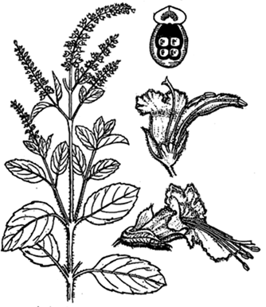
7. In a science class, students discussed that if a couple has two daughters, they will surely have a son next. Based on your knowledge of sex determination, is this belief scientifically valid? Why or why not?
8. Write any two differences between RNA and DNA on the basis of function and nitrogen bases present in them.
9. Where is the image formed when a convex lens receives light rays from a very distant object? Explain with the help of ray diagram.
10. A satellite of mass 500 kg is orbiting the Earth at a height of 300 km above the surface. Given the mass of Earth = 5.97×${10}^{24}$ kg, radius of Earth = $6.37×{10}^{6}$ m, calculate the gravitational force acting on the satellite.
11. A metal block weighs 100 N in air and 84 N when fully immersed in a liquid of density 1200 kg/m³. Calculate the volume of the block and identify whether the liquid is water or not.
12. Draw a graph to show the variation of volume of water with temperature in the range 0⁰C to 10⁰C.
13. Some scientists believe the universe might end in a "Big Rip (open universe)" What does this theory suggest, and how is it different from the "Big Crunch"?

14. In an experiment, a student reacts magnesium ribbon with hydrochloric acid at different concentrations. Predict how changing the concentration of acid will affect the rate of reaction and explain the reason based on collision theory.

15. Study the diagram of the electro-refining of impure copper setup below and answer the question.
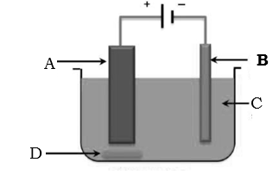
a) Identify A and B.
b) Explain what happens to the impure copper at the anode during electro-refining. Suggest two ways for the sustainable solution of the problem.
16. A community near a river uses chemical fertilizers heavily in farming. Over time, they observed an unusual growth of algae in the river water, and fish began to die. Suggest two ways for the sustainable solution of the problem.

Group D

Long answer type question. 7×7Ö28
17. Draw a chart showing the classification of kingdom Animalia and write two distinguishing characteristics of sub division gymnosperm.
18. Describe Mendel’s Law of Segregation. How does this law explain the reappearance of the recessive trait in the F₂ generation? Justify using the filial chart diagram.
19. Study the diagram below and answer the following question.
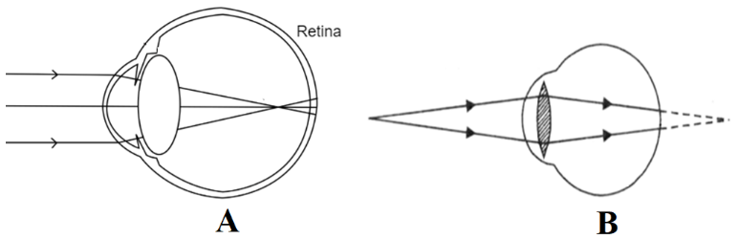

i) Which type of defect is shown in eye B?
ii) What is the cause of defect in eye A?
iii) Write any on remedy of the defect in eye B.
iv) What happens when rod cells of retina do not function properly?
20. How do analog and digital communication systems differ in terms of signal transmission, error handling, and data storage? Explain their advantages and disadvantages with suitable examples.
21. Three metal blocks P, Q, and R of equal masses are heated in the same furnace for the same amount of time. The rise in temperature of each block is given in the table.
Metal | P | Q | R
Increase in temperature | 45℃ | 38℃ | 52℃
i) Which metal has the lowest specific heat capacity? Why?
ii) If all three metal blocks at the same temperature are left to cool in
the same environment, which one will cool down faster? Why?
22. The following questions are based on the part of the modern periodic table given below:
 | Group 1 | Group 2 | Group 13 | Group 14 | Group 15 | Group 16 | Group 17 | Group 18
Period 2 | Li | Be | B | C | N | O | F | Ne
Period 3 | Na | Mg | Al | Si | P | S | Cl | Ar
i. Without writing the name, sketch the atomic structure of the
element that is the least reactive metal in the table. (1)
ii. A metal in the table has valency 1 and 3 shells. Write the balanced
chemical reaction between this metal and a non-metal with valency 3 and 2 shells. (2)
iii. The non-metals in Period 2 are given in random order: C, N, O, F. Arrange them in ascending order of atomic size. (1)
23. A student attempted to prepare ammonia gas in the laboratory by
heating a mixture of ammonium chloride and slaked lime, but tried to
collect it over water.
a) Draw a labeled diagram showing the correct apparatus and method
for ammonia collection. (2)
b) Explain why ammonia cannot be collected over water, relating your answer to its physical properties. (1)
c) Mention one chemical property of ammonia that justifies its use in
fertilizers. (1)

